Exercise 1: Configuring a Basic Spring Application
Scenario:
Your company is developing a web application for managing a library. You need to use the Spring Framework to handle the backend operations.
Steps:
- Set Up a Spring Project:
  - Create a Maven project named LibraryManagement.
  - Add Spring Core dependencies in the pom.xml file.
- Configure the Application Context:
  - Create an XML configuration file named applicationContext.xml in the src/main/resources directory.
  - Define beans for BookService and BookRepository in the XML file.
- Define Service and Repository Classes:
  - Create a package com.library.service and add a class BookService.
  - Create a package com.library.repository and add a class BookRepository.
- Run the Application:
  - Create a main class to load the Spring context and test the configuration.
Exercise 2: Implementing Dependency Injection
Scenario:
In the library management application, you need to manage the dependencies between the BookService and BookRepository classes using Spring's IoC and DI.
Steps:
- Modify the XML Configuration:
  - Update applicationContext.xml to wire BookRepository into BookService.
- Update the BookService Class:
  - Ensure that BookService class has a setter method for BookRepository.
- Test the Configuration:
  - Run the LibraryManagementApplication main class to verify the dependency injection.

SOLUTION:
Pom.xml
<?xml version="1.0" encoding="UTF-8"?>
<project xmlns="http://maven.apache.org/POM/4.0.0"
xmlns:xsi="http://www.w3.org/2001/XMLSchema-instance"
xsi:schemaLocation="http://maven.apache.org/POM/4.0.0 http://maven.apache.org/xsd/maven-4.0.0.xsd">
<modelVersion>4.0.0</modelVersion>
<groupId>com.library</groupId>
<artifactId>LibraryManagement</artifactId>
<version>1.0-SNAPSHOT</version>
<properties>
<maven.compiler.source>21</maven.compiler.source>
<maven.compiler.target>21</maven.compiler.target>
<project.build.sourceEncoding>UTF-8</project.build.sourceEncoding>
</properties>
<dependencies>
<dependency>
<groupId>org.springframework</groupId>
<artifactId>spring-context</artifactId>
<version>6.1.5</version>
</dependency>
</dependencies>
</project>
Book repository:
package com.library.repository;
public class BookRepository {
public void saveData() {
System.out.println("Success: Book data saved to the database!");
}
}
book service:
package com.library.service;
import com.library.repository.BookRepository;
public class BookService {
private BookRepository bookRepository;
public void setBookRepository(BookRepository bookrepository){
this.bookRepository = bookrepository;
}
public void registerBook(){
System.out.println("Service: Processing book registration....");
bookRepository.saveData();
}
}
Main Application:
package com.library;
import org.springframework.context.ApplicationContext;
import org.springframework.context.support.ClassPathXmlApplicationContext;
import com.library.service.BookService;
public class MainApplication {
public static void main(String[] args) {
ApplicationContext context = new ClassPathXmlApplicationContext("applicationContext.xml");
BookService bookService = (BookService) context.getBean("myService");
bookService.registerBook();
}
}
RESULT:
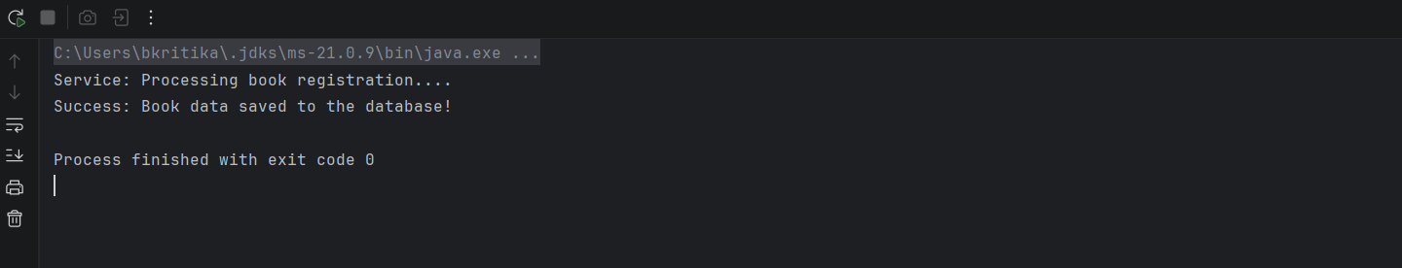

Exercise 4: Creating and Configuring a Maven Project
Scenario:
You need to set up a new Maven project for the library management application and add Spring dependencies.
Steps:
- Create a New Maven Project:
  - Create a new Maven project named LibraryManagement.
- Add Spring Dependencies in pom.xml:
  - Include dependencies for Spring Context, Spring AOP, and Spring WebMVC.
- Configure Maven Plugins:
  - Configure the Maven Compiler Plugin for Java version 1.8 in the pom.xml file.
SOLUTION:
BookService.java
package com.library;
import org.springframework.stereotype.Service;
@Service
public class BookService {
public void getLibraryWelcomeMessage() {
System.out.println("Welcome to the Library Management System!");
System.out.println("Spring Context is running perfectly.");
}
}
AppConfig.java:
package com.library;
import org.springframework.context.annotation.ComponentScan;
import org.springframework.context.annotation.Configuration;
@Configuration
@ComponentScan(basePackages = "com.library")
public class AppConfig {
}
MainApplication.java:
package com.library;
import org.springframework.context.annotation.AnnotationConfigApplicationContext;
public class MainApplication {
public static void main(String[] args) {
// 1. Initialize the Spring Application Context using our config class
AnnotationConfigApplicationContext context =
new AnnotationConfigApplicationContext(AppConfig.class);
// 2. Retrieve the BookService bean from the Spring container
BookService bookService = context.getBean(BookService.class);
// 3. Call the method to verify it works
bookService.getLibraryWelcomeMessage();
// 4. Close the context safely
context.close();
}
}
RESULT:
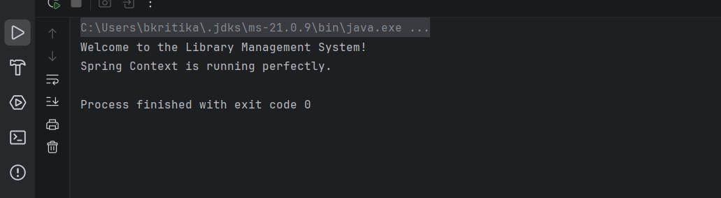
Exercise 5: Configuring the Spring IoC Container
Scenario:
The library management application requires a central configuration for beans and dependencies.
Steps:
- Create Spring Configuration File:
  - Create an XML configuration file named applicationContext.xml in the src/main/resources directory.
  - Define beans for BookService and BookRepository in the XML file.
- Update the BookService Class:
  - Ensure that the BookService class has a setter method for BookRepository.
- Run the Application:
  - Create a main class to load the Spring context and test the configuration.
SOLUTION:
BookRepository:
package com.library;

public class BookRepository {
public void saveData() {
System.out.println("Book data successfully saved to the database!");
}
}
BookService:
package com.library;
public class BookService {
private BookRepository bookRepository;
public void setBookRepository(BookRepository bookRepository) {
this.bookRepository = bookRepository;
}
public void executeSave() {
System.out.println("BookService is executing save operation...");
bookRepository.saveData();
}
}
applicationContext.xml:
<?xml version="1.0" encoding="UTF-8"?>
<beans xmlns="http://www.springframework.org/schema/beans"
xmlns:xsi="http://www.w3.org/2001/XMLSchema-instance"
xsi:schemaLocation="http://www.springframework.org/schema/beans
http://www.springframework.org/schema/beans/spring-beans.xsd">
<bean id="bookRepository" class="com.library.BookRepository" />
<bean id="bookService" class="com.library.BookService">
<property name="bookRepository" ref="bookRepository" />
</bean>
</beans>
MainApplication.java:
package com.library;
import org.springframework.context.ApplicationContext;
import org.springframework.context.support.ClassPathXmlApplicationContext;
public class MainApplication {
public static void main(String[] args) {
ApplicationContext context = new ClassPathXmlApplicationContext("applicationContext.xml");
BookService bookService = (BookService) context.getBean("bookService");
bookService.executeSave();
}
}
RESULT:
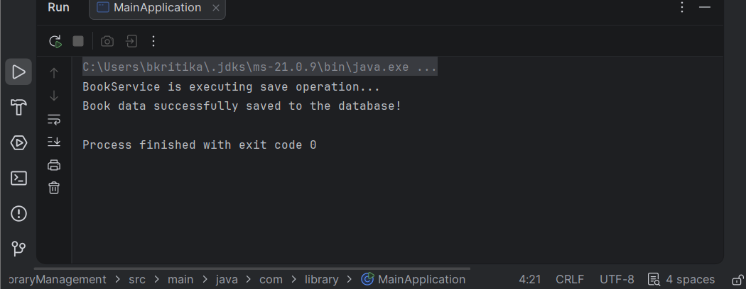

Exercise 7: Implementing Constructor and Setter Injection
Scenario:
The library management application requires both constructor and setter injection for better control over bean initialization.
Steps:
- Configure Constructor Injection:
  - Update applicationContext.xml to configure constructor injection for BookService.
- Configure Setter Injection:
  - Ensure that the BookService class has a setter method for BookRepository and configure it in applicationContext.xml.
- Test the Injection:
  - Run the LibraryManagementApplication main class to verify both constructor and setter injection.
SOLUTION:
BookRepository:
package com.library;

public class BookRepository {
public void saveData() {
System.out.println("Book data successfully saved to the database!");
}
}
BookService:
package com.library;
public class BookService {
private final EmailService emailService;
private BookRepository bookRepository;
public BookService(EmailService emailService) {
this.emailService = emailService;
System.out.println("-> Constructor Injection: EmailService initialized.");
}
public void setBookRepository(BookRepository bookRepository) {
this.bookRepository = bookRepository;
System.out.println("-> Setter Injection: BookRepository initialized.");
}
public void completeBookTransaction(String bookName) {
System.out.println("\nProcessing transaction for: " + bookName);
bookRepository.saveData();
emailService.sendNotification("Book '" + bookName + "' has been issued successfully.");
}
}
EmailService:
package com.library;
public class EmailService {
public void sendNotification(String message) {
System.out.println("Notification Alert: " + message);
}
}
MainApplication:
package com.library;
import org.springframework.context.ApplicationContext;
import org.springframework.context.support.ClassPathXmlApplicationContext;
public class MainApplication {
public static void main(String[] args) {
System.out.println("=== Bootstrapping Spring Container ===");
ApplicationContext context = new ClassPathXmlApplicationContext("applicationContext.xml");
System.out.println("\n=== Retrieving and Running Service ===");
BookService bookService = (BookService) context.getBean("bookService");
bookService.completeBookTransaction("The Great Gatsby");
}
}
applicationContext:
<?xml version="1.0" encoding="UTF-8"?>
<beans xmlns="http://www.springframework.org/schema/beans"
xmlns:xsi="http://www.w3.org/2001/XMLSchema-instance"
xsi:schemaLocation="http://www.springframework.org/schema/beans
http://www.springframework.org/schema/beans/spring-beans.xsd">
<bean id="bookRepository" class="com.library.BookRepository" />
<bean id="emailService" class="com.library.EmailService" />
<bean id="bookService" class="com.library.BookService">
<constructor-arg ref="emailService" />
<property name="bookRepository" ref="bookRepository" />
</bean>
RESULT:
Exercise 9: Creating a Spring Boot Application
Scenario:
You need to create a Spring Boot application for the library management system to simplify configuration and deployment.
Steps:
- Create a Spring Boot Project:
  - Use Spring Initializr to create a new Spring Boot project named LibraryManagement.
- Add Dependencies:
  - Include dependencies for Spring Web, Spring Data JPA, and H2 Database.
- Create Application Properties:
  - Configure database connection properties in application.properties.
- Define Entities and Repositories:
  - Create Book entity and BookRepository interface.
- Create a REST Controller:
  - Create a BookController class to handle CRUD operations.
- Run the Application:
  - Run the Spring Boot application and test the REST endpoints.
SOLUTION:
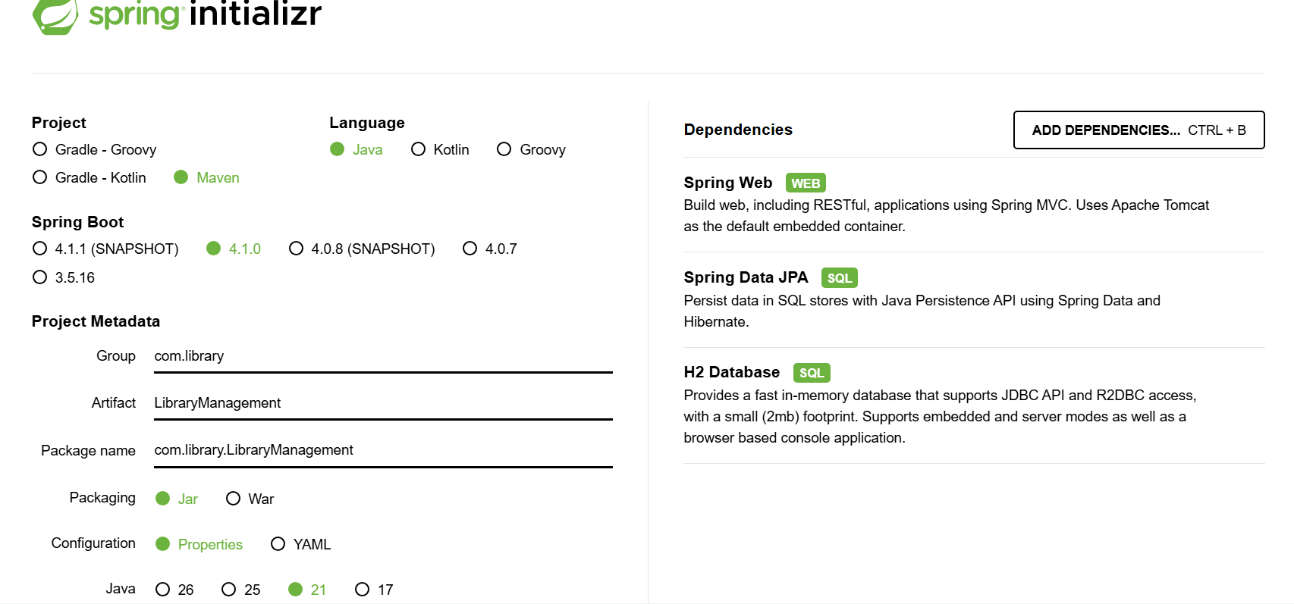
Applicationproperties:
spring.datasource.url=jdbc:h2:mem:librarydb
spring.datasource.driverClassName=org.h2.Driver
spring.datasource.username=sa
spring.datasource.password=
spring.jpa.database-platform=org.hibernate.dialect.H2Dialect
spring.h2.console.enabled=true
spring.jpa.show-sql=true
spring.jpa.hibernate.ddl-auto=update
Book:
package com.library.LibraryManagement.model;
import jakarta.persistence.Entity;
import jakarta.persistence.GeneratedValue;
import jakarta.persistence.GenerationType;
import jakarta.persistence.Id;

@Entity
public class Book {

@Id
@GeneratedValue(strategy = GenerationType.IDENTITY)
private Long id;
private String title;
private String author;
private String isbn;
public Book() {}
public Book(String title, String author, String isbn) {
this.title = title;
this.author = author;
this.isbn = isbn;
}
public Long getId() { return id; }
public void setId(Long id) { this.id = id; }

public String getTitle() { return title; }
public void setTitle(String title) { this.title = title; }

public String getAuthor() { return author; }
public void setAuthor(String author) { this.author = author; }

public String getIsbn() { return isbn; }
public void setIsbn(String isbn) { this.isbn = isbn; }
}
BookRepository:
package com.library.LibraryManagement.repository;

import com.library.LibraryManagement.model.Book;
import org.springframework.data.jpa.repository.JpaRepository;
import org.springframework.stereotype.Repository;
@Repository
public interface BookRepository extends JpaRepository<Book, Long> {
}
BookController:
package com.library.LibraryManagement.controller;
import com.library.LibraryManagement.model.Book;
import com.library.LibraryManagement.repository.BookRepository;
import org.springframework.beans.factory.annotation.Autowired;
import org.springframework.http.ResponseEntity;
import org.springframework.web.bind.annotation.*;
import java.util.List;

@RestController
@RequestMapping("/api/books")
public class BookController {

@Autowired
private BookRepository bookRepository;
@PostMapping
public Book createBook(@RequestBody Book book) {
return bookRepository.save(book);
}
@SuppressWarnings("unused")
@GetMapping
public List<Book> getAllBooks() {
return bookRepository.findAll();
}

@GetMapping("/{id}")
public ResponseEntity<Book> getBookById(@PathVariable Long id) {
return bookRepository.findById(id)
.map(book -> ResponseEntity.ok().body(book))
.orElse(ResponseEntity.notFound().build());
}
@PutMapping("/{id}")
public ResponseEntity<Book> updateBook(@PathVariable Long id, @RequestBody Book bookDetails) {
return bookRepository.findById(id)
.map(book -> {
book.setTitle(bookDetails.getTitle());
book.setAuthor(bookDetails.getAuthor());
book.setIsbn(bookDetails.getIsbn());
Book updatedBook = bookRepository.save(book);
return ResponseEntity.ok().body(updatedBook);
}).orElse(ResponseEntity.notFound().build());
}
@DeleteMapping("/{id}")
public ResponseEntity<Void> deleteBook(@PathVariable Long id) {
return bookRepository.findById(id)
.map(book -> {
bookRepository.delete(book);
return ResponseEntity.ok().<Void>build();
}).orElse(ResponseEntity.notFound().build());
}
}
Body(JSON):
{
"title": "The Hobbit - Extended Edition",
"author": "J.R.R. Tolkien",
"isbn": "9780261102217"
}
Result:
